1.

n = int(input())

print(n,' - Кол-во вершин')

m = []

for i in range(n):

m.append(input().split())

print('-----------')

for i in range(n):

sum = 0

k = ''

for j in range(n):

if(m[i][j] == '1'):

sum = sum + 1

k = k + str(j+1) + " "

print("sum =", sum,",", i+1, ":", k)

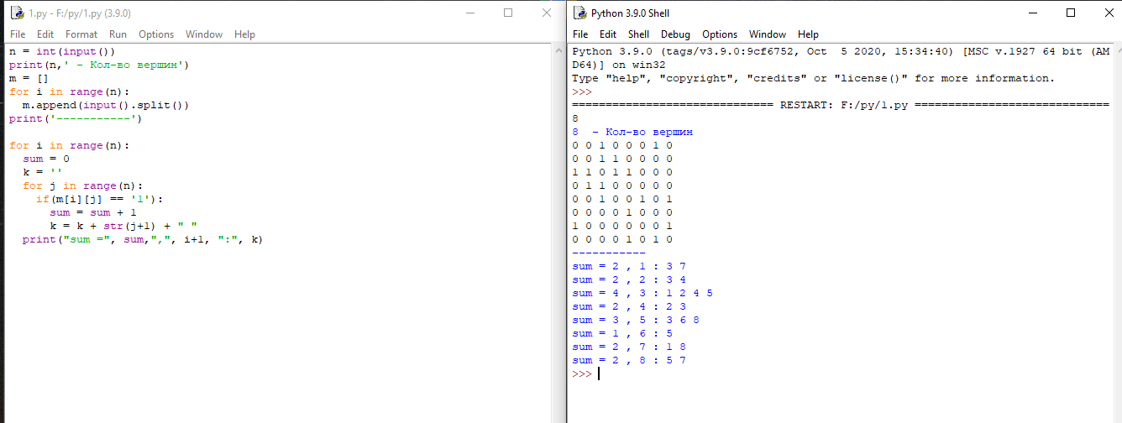

2

a = int(input())

b = int(input())

aa = []

for i in range (a):

aa.append([])

for i in range(b):

с = input().split()

first = int(с[0])-1

second = int(с[1])-1

aa[first].append(second+1)

aa[second].append(first+1)

for i in range(a):

k = str(sorted(aa[i]))

k= k.replace('[', '')

k= k.replace(']', '')

print(i+1, ":", k)

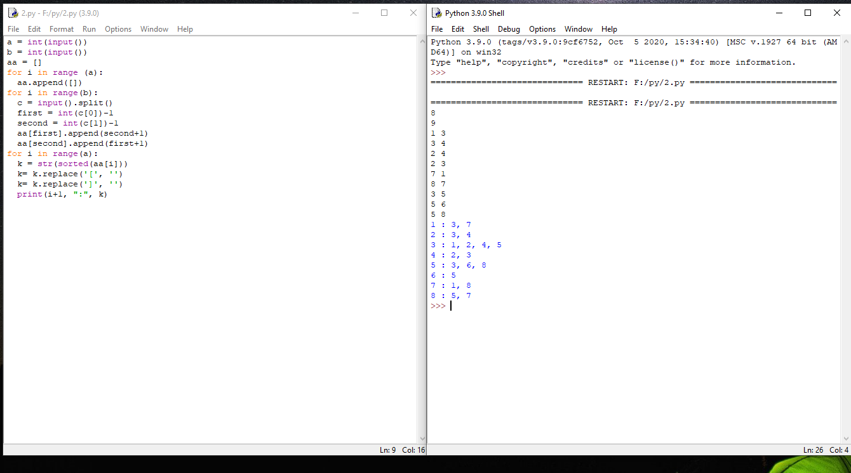

3.

a = int(input("количество вершин = "))

l = []

p = []

print("cписок смежности: ")

for i in range(a):

s = input().split(":")

s[1] = s[1].split(',')

l.append(s[1])

for i in range(a):

for j in range(len(l[i])):

p.append([int(i+1),int(l[i][j])])

print("------------")

p2 = p.copy()

for i in range(len(p)):

for j in range(len(p)):

f1 = int(p[i][0])

s1 = int(p[i][1])

f2 = int(p[j][0])

s2 = int(p[j][1])

if(f1 == s2 and s1 == f2):

p2.remove(p[i])

p[i].reverse()

print("cписок ребер:")

for i in range(len(p2)):

print(p2[i])

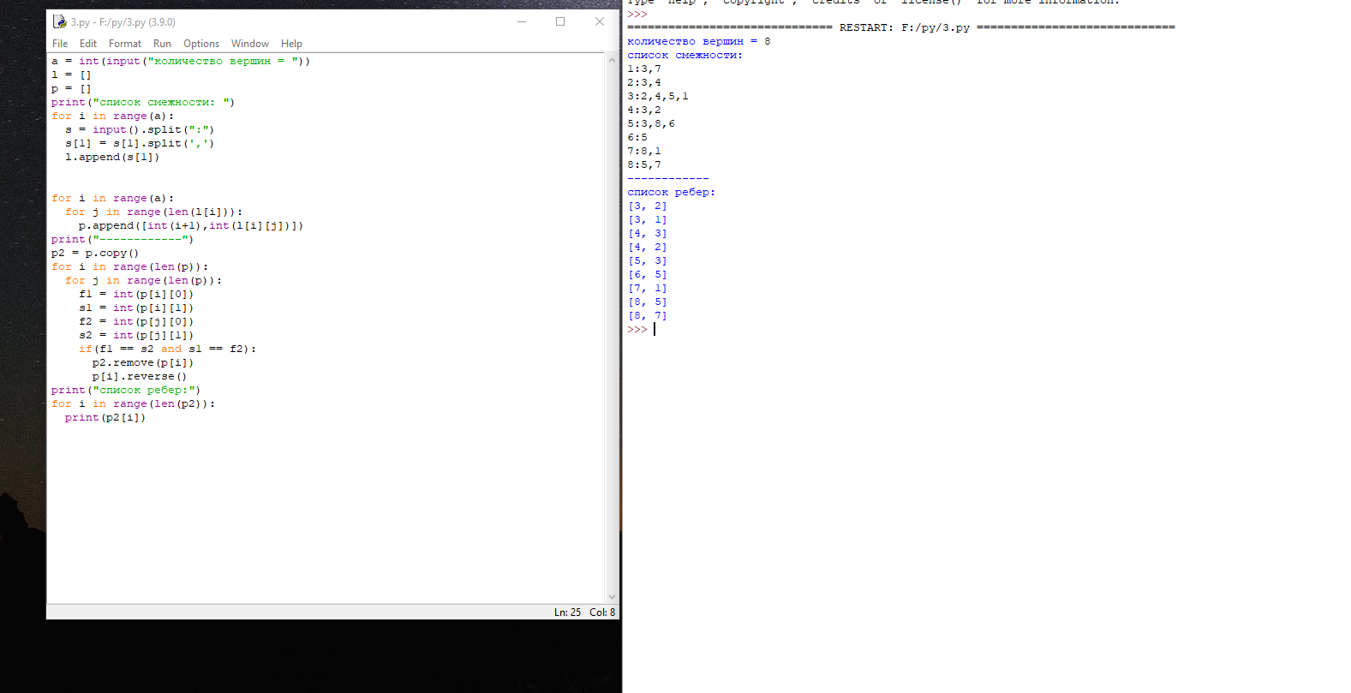

4

c = input().split()

b = int(c[0])

m = int(c[1])

#смежности

a = []

for i in range (b):

a.append([])

for i in range(m):

s = input().split()

first = int(s[0])-1

second = int(s[1])-1

a[first].append(second+1)

a[second].append(first+1)

#исходная точка

v = int(input())

op = []

a_smezh = [False for i in range(len(a))]

def aaa(node):

a_smezh[node-1] = True

op.append(node)

t = 0

for neighbor in a[node-1]:

if a_smezh[neighbor-1]:

t = t + 1

if not a_smezh[neighbor-1]:

aaa(neighbor)

if t == len(a[node-1]):

op.append(node-1)

aaa(v)

print("смежность:")

print(a)

print("кол-во ходов:")

print(len(op))

print("точки:")

print(op)

